**Project Title:**

**Application of Wheatstone Bridge using LDR – Replaced by Piezoelectric Disc**

**Course Name and Code: LINEAR INTEGRATED CIRCUITS**

**20EEIC216**

**Faculty In charge Name: PROF.POORNIMA PATIL**

**Team Members**



**Abstract**:

Integrating an LDR and a piezoelectric disc into a Wheatstone bridge circuit enables the creation of a versatile system capable of harvesting renewable energy and monitoring environmental parameters.

By the battery we were giving input of 9V to the circuit but by replacing the electrical energy by renewable source i.e., piezoelectric disc produced by vibrations and all gives around 3-5V by single disc and usage of 2disc produces 5-9V.

**Table of Contents: List of sections and page numbers.**

1. **Introduction:**

Using a Wheatstone bridge with an LDR (Light Dependent Resistor) in conjunction with a piezoelectric disc for renewable energy applications can create a system capable of harvesting energy from both light and mechanical vibrations.

The Wheatstone bridge can be configured with one arm consisting of the LDR and another arm consisting of the piezoelectric disc. As light intensity or mechanical vibrations change, the resistance of these components changes, creating an imbalance in the bridge. This imbalance can be detected and measured using a galvanometer or other sensing circuitry.

By the battery we were giving input of 9V to the circuit but by replacing the electrical energy by renewable source i.e., piezoelectric disc produced by vibrations and all gives around 3-5V by single disc and usage of 2disc produces 5-9V.

* **1.1 Background**
  + **Introduction to the course project topic:**

Balanced bridge circuits find many useful electronics applications such as being used to measure changes in light intensity, pressure or strain. The types of resistive sensors that can be used within a wheatstone bridge circuit include: photo resistive sensors (LDR’s), positional sensors (potentiometers), piezoresistive sensors (strain gauges) and temperature sensors (thermistor’s), etc.

There are many Wheatstone bridge applications for sensing a whole range of mechanical and electrical quantities, but one very simple wheatstone bridge application is in the measurement of light by using a photo resistive device. One of the resistors within the bridge network is replaced by a light dependent resistor, or LDR.

An LDR, also known as a cadmium-sulphide (CDs) photocell, is a passive resistive sensor which converts changes in visible light levels into a change in resistance and hence a voltage. Light dependent resistors can be used for monitoring and measuring the level of light intensity, or whether a light source is ON or OFF.

* **Importance of linear integrated circuits in modern technology:**

Linear integrated circuits (ICs) play a crucial role in modern technology across various fields due to their ability to process continuous analog signals with high precision.

1.Signal Processing 7. Consumer Electronics

2. Low Power Consumption 8. Industrial Applications

3.Precision and Accuracy

4.Versatility

5.Integration

6.Communication Systems

* **1.2 Objectives**
  + **Clear statement of the project objectives.**

The objectives involved in this project are mainly focused on improving the renewable energy by replacing the electrical energy:

1.Light sensing with LDR 5.Piezoelectric Energy Harvesting

2.Signal Amplification and Conditioning 6.Energy Efficient and Sustainable

3.Calibration and Optimization 7.Application in Low Power

4.Prototyping and testing

* **1.3 Relevance to SDGs**
  + **Explanation of which Sustainable Development Goals the project addresses and how.**

Our Project Addresses on the topic of Sustainable Development Goals no 7:**ENSURE ACCESS TO AFFORDABLE,RELIABLE,SUSTAINABLE AND MODERN ENERGY FOR ALL**

* **Renewable Energy Harvesting**: By combining the light sensitivity of the LDR with the mechanical energy harvesting capability of the piezoelectric disc, this system can efficiently capture energy from multiple renewable sources.
* **Sensing and Monitoring**: The Wheatstone bridge configuration allows for precise measurement of changes in light intensity and mechanical vibrations, making it suitable for applications such as environmental monitoring, security systems, or smart infrastructure.
* In summary,

Integrating an LDR and a piezoelectric disc into a Wheatstone bridge circuit enables the creation of a versatile system capable of harvesting renewable energy and monitoring environmental parameters.

By the battery we were giving input of 9V to the circuit but by replacing the electrical energy by renewable source i.e., piezoelectric disc produced by vibrations and all gives around 3-5V by single disc and usage of 2disc produces 5-9V.

#### Methodology

* 1. **Project Design:** 
     1. **Block Diagram representation of the project**
     2. **Explanation of the block diagram**

The **Wheatstone Bridge** has many uses in electronic circuits other than comparing an unknown resistance with a known resistance. When used with **Operational Amplifiers, the Wheatstone bridge circuit can be used to measure and amplify small changes in resistance, RX due, for example, to changes in light intensity as we have seen above.**

But the bridge circuit is also **suitable for measuring the resistance change of other changing quantities, so by replacing the above photo-resistive LDR light sensor for a thermistor, pressure sensor, strain gauge, and other such transducers, as well as swapping the positions of the LDR and VR1, we can use them in a variety of other Wheatstone bridge applications.**

When **the piezo element in the pump receives the electrical voltage**, the **unimorph or bimorph actuator deforms to generate movement through the pump. Liquid cooling systems for CPUs computer, LED lights, etc. also utilize piezoelectric discs.**

* + 1. **Components used**

|  |  |  |
| --- | --- | --- |
| **Components** | **Specification** | **Quantity** |
| **1.OP-AMP** | **IC741** | **1** |
| **2.Potentiometer** | **1K(102)** | **1** |
| **3.Resistor** | **10kohm ,1/4 watt 220ohm,1/4 watt** | **1 each** |
| **4.Photoresistor(LDR)** | **-** | **1** |
| **5.Piezoelectric Disc(Renewable source)** | **3-9V** | **2** |
| **6.Wires** | **Single Stranded** | **Assorted** |
| **7.Breadboard** | **-** | **1** |
| **8.PCB** | **-** | **1** |

* 1. **Sensor Information:**
     1. **Refer data sheet to tabulate the specifications of the sensor include any timing diagram of the sensor, minimum and maximum values as inputs and outputs. All the values should be tabulated.**

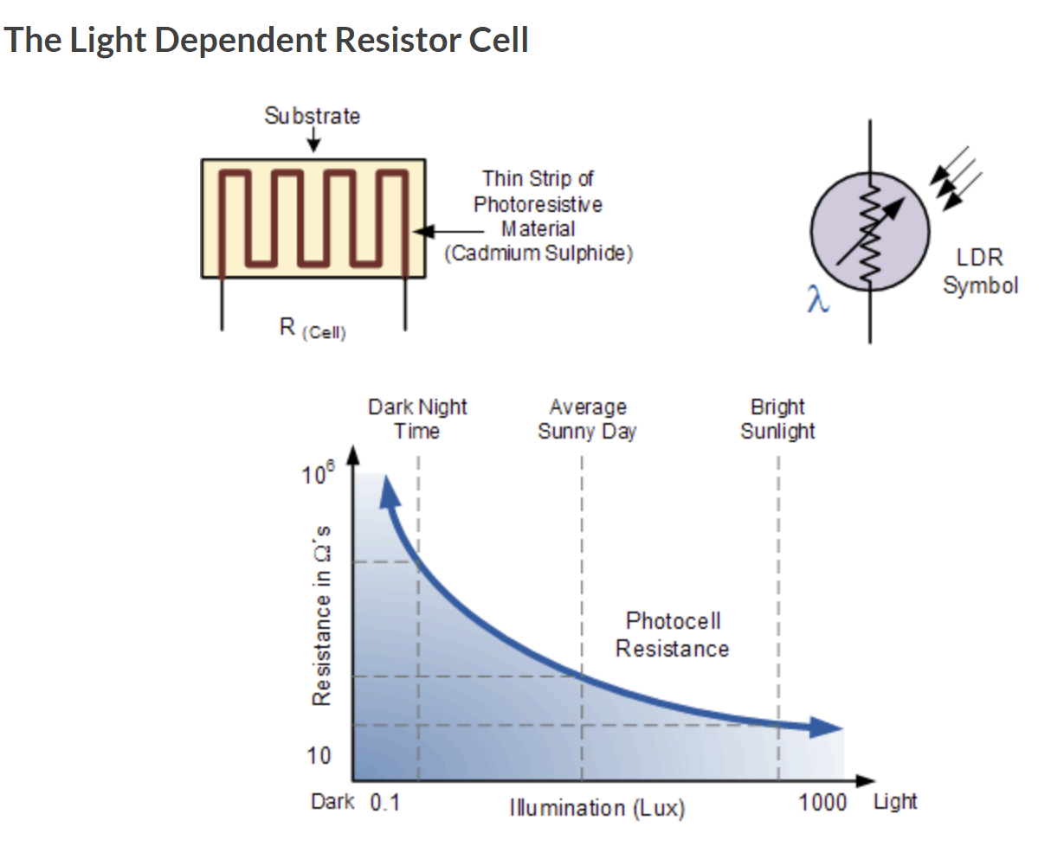

* + 1. **Sensor Characterization : Using experimental approach arrive at the relationship between physical quantity and electrical quantity**

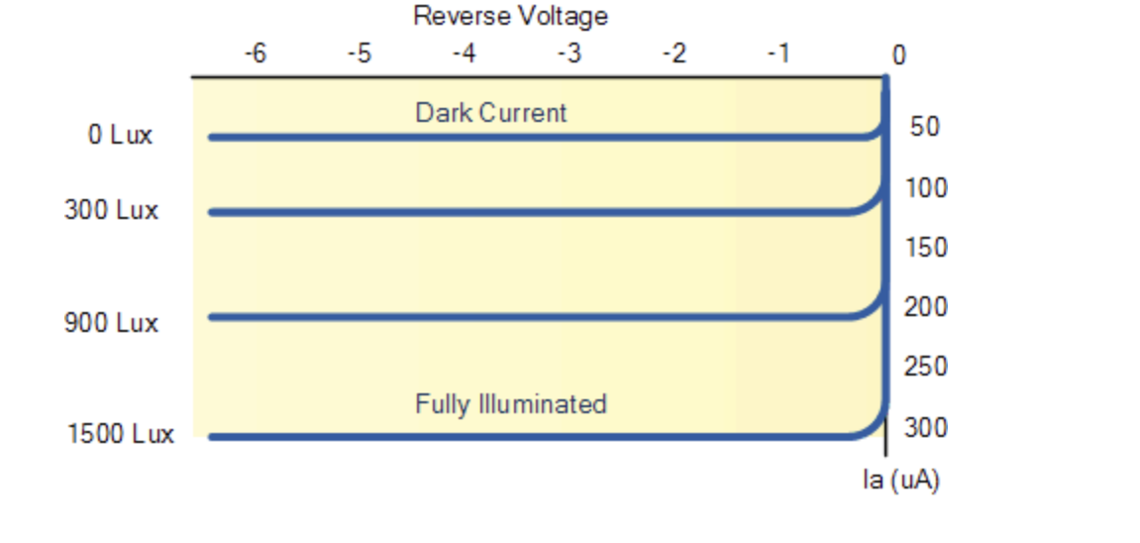

**Sample Example: LIGHT DETECTING SENSOR**

|  |  |
| --- | --- |
| **Illuminance in lux** | **Voltage or Current or Resistance** |
| **0 Lux** | **50uA** |
| **300Lux** | **100uA** |
| **900 Lux** | **200uA** |

**Input output Characteristics**

Input : distance in ‘cm’ on X-axis

Output: Current in ‘uA’ on Y-axis

Sensitivity from the above transfer curve is:

Expected: -65

Experimental: -57db

1. **Circuit Design and Simulation**
   1. **Circuit Diagram: Explanation and design of the circuit and listing the specifications of the circuit components**

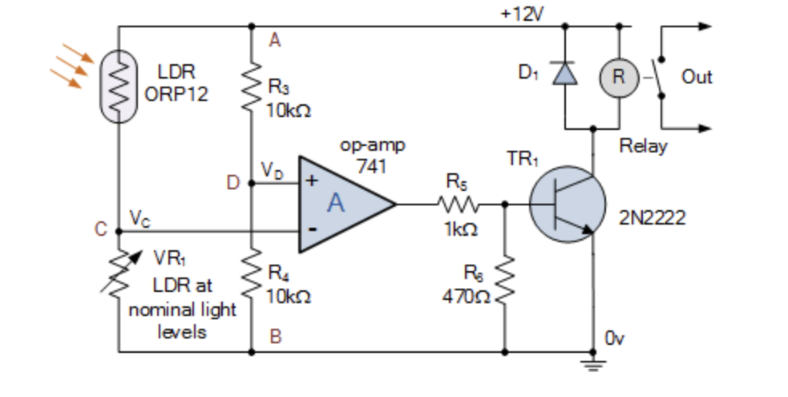

* 1. **Simulation setup and tools.**
     1. Detailed schematic of the Op-Amp circuit.

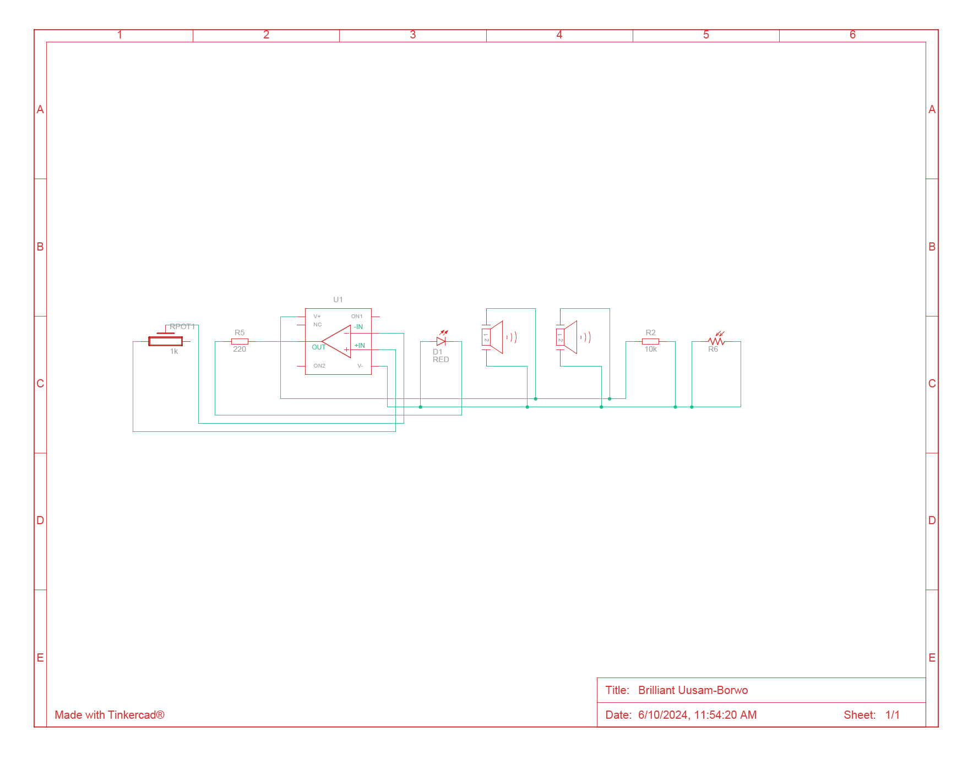

* + 1. Description of the simulation environment (ex: Spice software, Proteus, Eagle)

**Tinker cad circuit simulation tool**

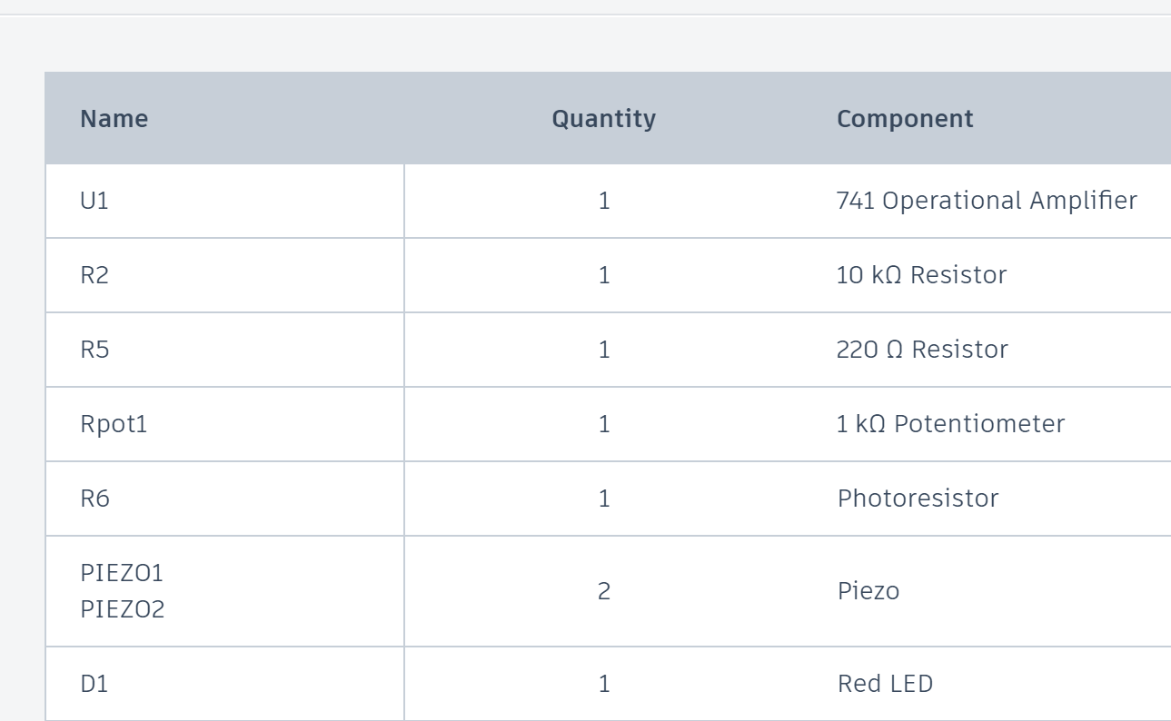

* + 1. Snap shots of the circuit and output with explanation

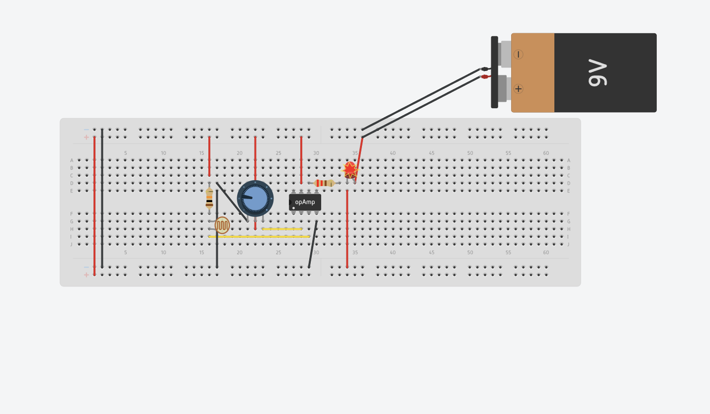

Replaced renewable energy

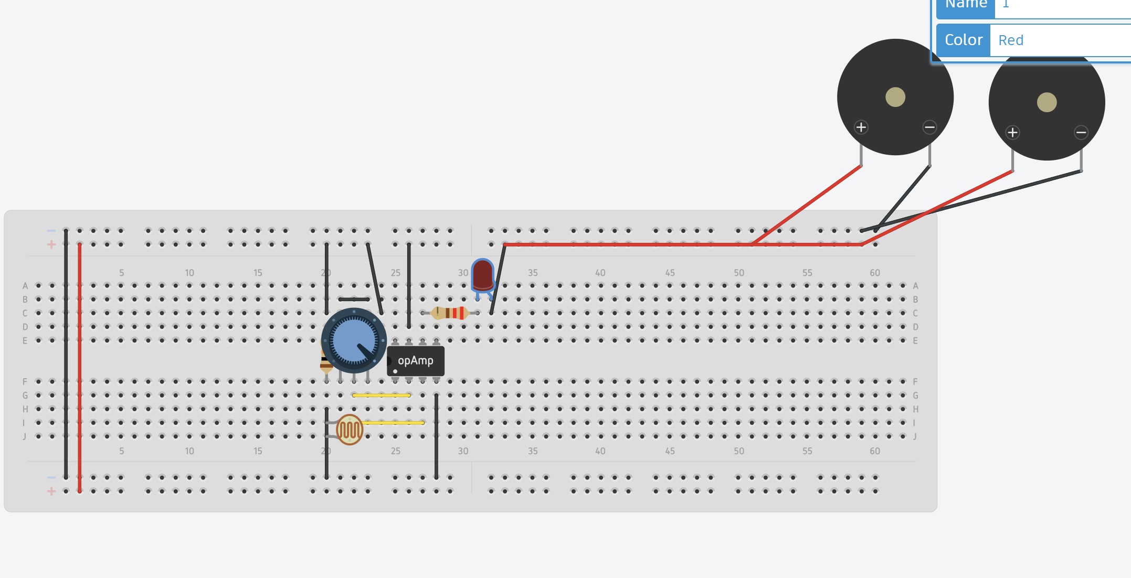

**3.3Implementation:**

**Application of Wheatstone Bridge using LDR – Replaced by Piezoelectric Disc**

Step-by-step process of the project implementation.

* + 1. Snap shots of the circuit Bread Board and PCB

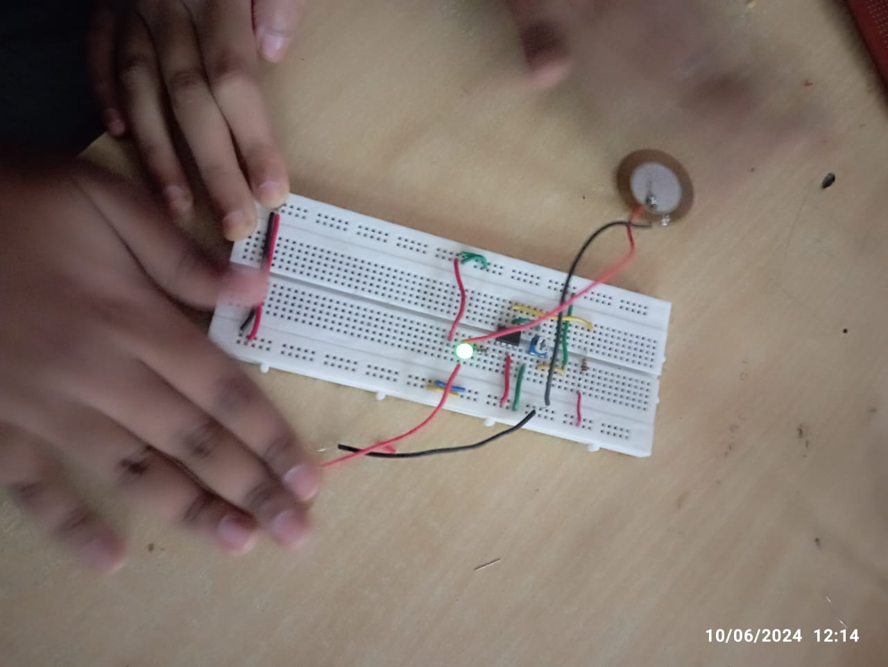

1. **Results and Discussions**
   1. **Data and observations from practical implementation.**

|  |  |
| --- | --- |
| 1. **Illuminance in lux** | **Voltage or Current or Resistance** |
| **0 Lux** | **50uA** |
| **300Lux** | **100uA** |
| **900 Lux** | **200uA** |

* 1. **Comparison with simulation results.**

The simulation results are quite similar but the voltage range is less as compared to the electric battery

By replacing the piezoelectric disc produces around 3-9 V of voltage.

1. **Overview of SDG**
   1. **Explanation of SDG in general**

**In September 2015 Heads of State and Government** agreed to **set the world on a path towards sustainable development through the adoption of the**[**2030 Agenda for Sustainable Development**](https://sustainabledevelopment.un.org/post2015/transformingourworld)**.** Earlier it was adopted to address the world’s urgent environmental , political and economic challenges and many more ongoing challenges in the universe.

**The main motto is at addressing to end the poverty , protect the planet and ensure that all the living beings including the people enjoy the peace and prosperity.** The SDGs build upon the success of the Millennium Development Goals (MDGs) but encompass a broader scope, incorporating environmental sustainability, economic development, and social inclusion.

This agenda includes 17 Sustainable Development Goals, or SDGs, which set out quantitative objectives across the social, economic, and environmental dimensions of sustainable development — all to be achieved by 2030. The **goals provide a framework** for shared action **“for people, planet and prosperity,”** to be implemented by **“all countries and all stakeholders, acting in collaborative partnership.”**

* 1. **Discussion on how the project outcomes contribute to the targeted SDGs (SDG 7).**
  2. **Any limitations and potential improvements**

No limitations as far . its executed in the simulation and on the PCB SUCCESSFULLY.

1. **Conclusions:.**

Integrating an LDR and a piezoelectric disc into a Wheatstone bridge circuit enables the creation of a versatile system capable of harvesting renewable energy and monitoring environmental parameters.

By the battery we were giving input of 9V to the circuit but by replacing the electrical energy by renewable source i.e., piezoelectric disc produced by vibrations and all gives around 3-5V by single disc and usage of 2disc produces 5-9V.

* **Renewable Energy Harvesting**: By combining the light sensitivity of the LDR with the mechanical energy harvesting capability of the piezoelectric disc, this system can efficiently capture energy from multiple renewable sources.
* **Sensing and Monitoring**: The Wheatstone bridge configuration allows for precise measurement of changes in light intensity and mechanical vibrations, making it suitable for applications such as environmental monitoring, security systems, or smart infrastructure.